Areas of Research and Research groups within the Physics Department
- Astronomy (as is)
- Laser and Optical Physics
- ARC Special Research Centre for Lasers and Applications (CLA) (As is)
- Laser Cleaning and Surface Modification (as is)
- Solid State Lasers (Judith to supply)
- Optics and Electronics of Solid State Materials
- Metalorganic Chemical Vapour Deposition Laboratory (hyperlink to p2)
- GaSb quantum dots (hyperlink to QDs)
- Laser Assisted Chemical Vapour Deposition Laboratory (hyperlink to p3)
- Piezoelectric and Ferroelectric Materials (hyperlink to p4)
- III-V Nitrides (hyperlink to p5)
- Quantum Confinement (hyperlink to p6)
- Clean Room Facility (hyperlink to p7, will be supplemented by arrangements for commercial access))
- Optical Microcharacterisation Facility (hyperlink to p1)
- Theoretical Physics (links as before)
- Muscle Biophysics (as before)
Opportunities for postgraduate work towards a higher degree –MSc or PhD
- List of postgraduate projects currently offered (hyperlink to p8, to be updated))
- Research infrastructure available to postgraduate students (hyperlink to p9, to be done))

Metalorganic Chemical Vapour Deposition Laboratory (Associate Professor Ewa M. Goldys)

Metalorganic Chemical Vapour Deposition (MOCVD) is a technique of synthesis of semiconductor materials based on a chemical reaction of special chemicals called metalorganic precursors in a vapour phase (hence the name). The process is carried out using a commercial MOCVD reactor built by Thomas Swan. The metalorganic precursors are transported into the reactor chamber using hydrogen carrier gas. High temperature in the chamber decomposes the precursors and the liberated atoms recombine forming a semiconducting compound. This takes place on substrates placed on a radiatively heated susceptor resulting in film growth.

Paulos operates the MOCVD system

Present activities centre around growth, characterisation and device applications of antimonides. This group of semiconductors is characterised by a narrow bandgap with high speed capabilities and applications in infrared electronics. For several years we have been exploring growth of high quality undoped gallium antimonide and have established the optimum growth window and growth protocols. Variations of p-type doping level is achieved by adjustments of growth parameters We have also carried out successful n-type doping of GaSb using trimethylzinc. We continue our work on growth of high electronic quality undoped AlGaSb. Our present interests focus on growth of GaSb quantum dots, where we have achieved fascinating results described on the following page (hyperlink to a new page).

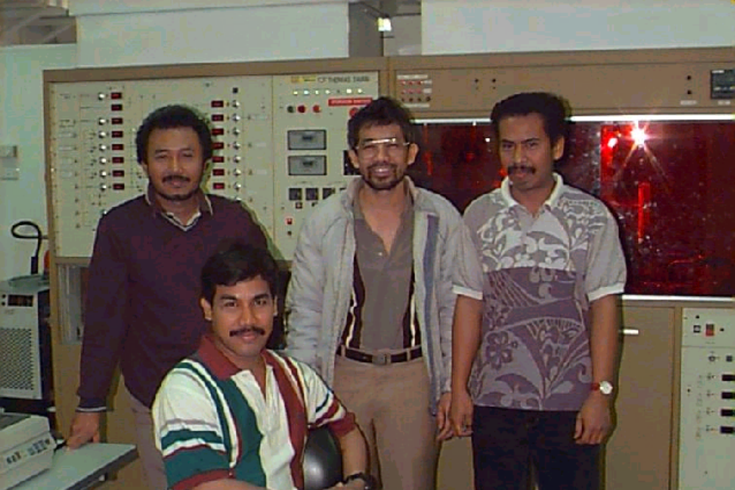
Past/present students involved in the antimonides (from left to right: Agus Subekti (expert on GaSb growth, Ari Ramelan (AlGaSb), Motlan (GaSb quantum dots) Paulos Gareso (GaSb/GaAs heterostructures)
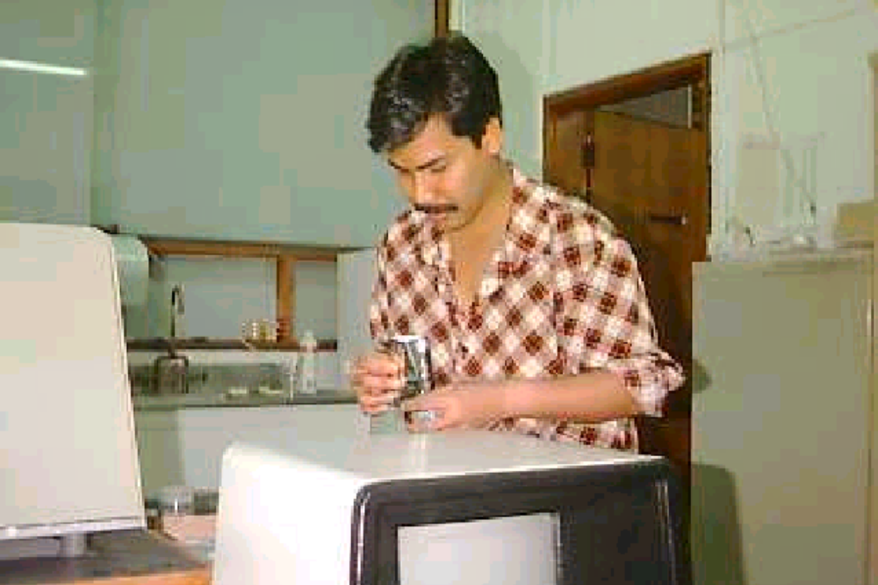
Ari hard at work

The antimonides are set to become the next hot topic in semiconductors (after silicon, GaAs and recently GaN). Their favourable combination of low effective mass and the bandgap corresponding to just below 1.5 micrometers wavelength make GaSb an ideal candidate for high speed light detectors. We currently offer a postgraduate project on light detection using GaSb, which will make use of our p-and n-type doping capabilities. Fabrication of the devices will take place in our fully equipped clean room.

Selected publications arising from this program include:

- A.Subekti, E.M. Goldys, T.L. Tansley,"Characterisation of undoped gallium antimonide grown by metalorganic chemical vapour deposition", J. Phys. Chem. Sol. 61, p. 537-44, (2000).
- A. Subekti, E.M. Goldys, Melissa J. Paterson, K. Drozdowicz-Tomsia, T.L. Tansley, "Atmospheric Pressure Chemical Vapour Deposition Growth Window for Undoped Gallium Antimonide", Journal of Materials Research, 14, p. 1238-45, (1999).
- A. Subekti, T.L. Tansley, E.M. Goldys, "Characterisation of microcrystalline GaN Grown on Quartz and on "Tunnelling transport in Al-n-GaSb Schottky diodes", IEEE Transaction on Electron Devices, vol 45 no 10, 2247 (1998).
- A.H. Ramelan, K. Drozdowicz-Tomsia, E.M. Goldys, T.L. Tansley, "Study of Optical and Electrical Properties of
GaSb/AlxGa1-xSb Grown by Metalorganic Chemical Vapour Deposition", accepted in J. Electron. Mat.
- A. Subekti, E.M. Goldys and T.L. Tansley, ''Growth of Gallium Antimonide (GaSb) by Metalorganic Chemical Vapour Epitaxy'', Conference on Optoelectronic and Microelectronic Materials and Devices, COMMAD96 8-11 Dec. 1996 Canberra, p. 426 (1997).
- K. Drozdowicz-Tomsia, Agus Subekti, E.M. Goldys and Melissa J. Paterson, "GaSb films and self-assembled islands grown by MOCVD", 16 General Conference of the Condensed Matter Division of the European Physical Society, 28 August - 28 August 1997, Leuven, Belgium.
- " A.H. Ramelan, K. Drozdowicz-Tomsia, E.M. Goldys, T.L. Tansley, " Study of Optical and Electrical Properties of GaSb/AlxGa1-xSb grown by MOCVD11-th International Semiconducting and Insulating Materials Conference Canberra Australia 3-7 July 2000.
- A.H. Ramelan, K.S.A. Butcher, E.M. Goldys, T.L. Tansley, Electrical Properties of Te-Doped MOCVD Grown GaSb Schottky Diodes, 2000 Conference on Optoelectronic and Microelectronic Materials and Devices, Melbourne, Australia, 6-8 December 2000

(For more information contact Associate Professor Ewa Goldys (hyperlink to home page) (goldys@ics.mq.edu.au)
GaSb quantum dots: (Associate Professor Ewa M. Goldys)

Quantum dots as new materials

Quantum dots are semiconductor nanostructures with all three dimensions of less than tens of nanometres, either deposited on or embedded in another semiconductor. The interest in quantum dots was initially driven by a desire to create a material with electronic density of states strongly modified by quantum confinement effects (a reduction in size to less than tens of nanometers) and approaching a delta-like density of states for a truly zero-dimensional system. Such a medium was perceived to offer significant advantages for example in ultra-low threshold semiconductor diode lasers, and also presented interesting opportunities for fundamental research in the area of light-matter interaction.

An important breakthrough has been realized with the development of the self-assembled growth procedures, which can be carried out both using MOCVD as well as MBE techniques (see for example D.J. Eaglesham, M. Cerullo, Phys. Rev. Lett., 64, 1943, (1990)). In the self-assembled growth the quantum dots are created from ultrathin layers (typically about 2 monolayers thick) which spontaneously break up due to strain between the substrate and the grown film, and minimize their energy by forming small scale islands. Size quantization in such islands has been demonstrated.

Self-assembled growth has proven to be an extremely fruitful technique which is now widely used. At Macquarie University we have made significant advances in material growth and understanding of the self-assembly growth process and its control. (Appl. Phys Lett. 73 , 1233, (1998)). We deposit GaSb quantum dots on GaAs using atmospheric pressure metalorganic chemical vapour deposition. The GaSb dots (islands) self-organise due to lattice mismatch of several percent between GaAs and GaSb. The dots can be visualised using a technique called Atomic Force Microscopy which gives us images such as shown here.

Studies of quantum dots attract significant interest worldwide, because of their fascinating new physics and unique potential for innovative electronic and optoelectronic devices. Actually, these innovative applications are just beginning to emerge. One of them involves using quantum dots for the detection of infrared light in devices similar to the previously explored quantum well intersubband detectors. Other interesting applications include use in quantum gates at the centre of a quantum computer.

The aim of our research on GaSb quantum dots was to establish a technology to fabricate a three dimensional quantum dot composite material, a building block for future electronic and optoelectronic devices. This is achieved by depositing multiple layers of quantum dots interspersed with quantum barriers of a different material. Interestingly, the dots show some degree of vertical correlation.
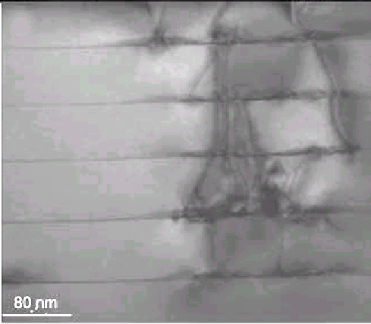

Our recent results include

- Demonstration of feasibility of QD growth using atmospheric pressure MOCVD. This is significant, because of an extremely rapid turnover time possible in such systems. We are able to complete the growth process (from loading the chamber to taking the sample out) within 1 hour, while the actual QD growth takes several seconds. Such short times indicate a process which may be industrially relevant.

- Establishment of growth protocols for growth of QDs with varying sizes and densities. Our aim was to grow a high density of small dots, and we have achieved ???? give numbers here.
- identification and understanding of growth evolution. Our systematic studies of growth evolution with variation of growth parameterts indicate a variety of different scenarios, where the dilution of precursors and the growth time both play a role, in addition to the commonly recognised influences of growth temperaature and the lattice mismatch.
- optical characterisation and analysis of optical emission. In embedded films we have observed optical (photoluminescence and cathodoluminescence)emission at energies about 1.0 eV, with peak energies following the trend in dot sizes. We interpret this by a combined effect of quantum confinement and interface intermixing.

- We have also compared GaSb dots embedded in GaAs with an opposite system of GaAs embedded in GaSb, and with a II-VI system of ZnTe dots in CdSe.

Our GaSb QD growth technology has reached the stage of maturity so that device applications can now be envisaged. We are interested in securing joint funding for quantum dot device researc, for example on quantum dot light detectors (hyperlink to new physics of QDs ). For more information contact Associate Professor Ewa Goldys (goldys@ics.mq.edu.au)

Follow this link to learn about new physics in quantum dots (hyperlink to new physics in quantum dots)

Our selected publications concerning quantum dots include:

- "Microstructural evolution of GaSb self-assembled islands grown by metalorganic chemical vapour deposition", B.M. Kinder and E.M. Goldys, Applied Physics Letters, vol. 73 no 9, p. 1233-5 (1998).

- "Cathodoluminescence study of multilayer GaSb/GaAs self-assembled quantum dots grown by MOCVD", Motlan, E.M. Goldys submitted to Applied Physics Letters

- "Cathodoluminescence studies of self-organised CdTe/ZnTe quantum dots", M. Godlewski, S. Mackowski, G. Karczewski, E.M. Goldys, M.R. Phillips, accepted in Semiconductor Science and Technology.

- ''GaAs in GaSb - a new type of heterostructure emitting at 2 um wavelength'', A.A. Toropov, V.A Solov'ev, B.Ya. Mel'tser, Ya.V. Terent'ev, S.V. Ivanov, P.S. Kop'ev,Motlan, and E. M. Goldys, submitted to Applied Physics Letters.

- "Growth Optimisation of GaSb/GaAs Self-assembled Quantum Dots Grown by MOCVD", Motlan, E.M. Goldys, T.L. Tansley, submitted to Journal of Crystal Growth.

- "Size and density control of MOCVD grown self-organized GaSb islands on GaAs" Motlan, E.M. Goldys, K. Drozdowicz-Tomsia, T.L. Tansley, COMMAD 1998, 14-16 December 1998, Perth, page 460-463.

- " Stages of formation and self-assembly of GaSb grown on GaAs by metalorganic chemical vapour deposition" B. M. Davies, E.M. Goldys, T.L. Tansley.,18 IUVSTA Workshop "Diffusion and Growth in Ultrathin Layers", Newcastle 17-21 November 1997 November (invited talk)

- "Metalorganic Chemical Vapour Deposition of GaSb Quantum Dots on Germanium", A. Subekti, M.J. Paterson, E. Goldys, T.L. Tansley, Thin Solid Films, vol 320, p. 166-8, (1998).

- "GaSb films and self-assembled islands grown by MOCVD", K. Drozdowicz-Tomsia, Agus Subekti, E.M. Goldys and Melissa J. Paterson, 16 General Conference of the Condensed Matter Division of the European Physical Society, 28 August - 28 August 1997, Leuven, Belgium.

- "The Influence of a Substrate on Self-Organised Island Nucleation Morphology of Metalorganic Chemical Vapour Deposited GaSb", A. Subekti, M.J. Paterson, {\bf E.M. Goldys} and T.L. Tansley, Applied Surface Science, vol 140, 190-6, (1999).

- " The effects of growth temperature on the structure of GaSb/GaAs quantum dots by MOCVD" Motlan, T.L. Tansley and E.M. Goldys, 11-th International Semiconducting and Insulating Materials Conference Canberra Australia 3-7 July 2000.

- "Scanning cathodoluminescence and electron microscopy of self-organised CdTe quantum dots" M. Godlewski, S. Mackowski, G. Karczewski, E.M. Goldys, M.R. Phillips, XXIX International School of Physics of Semiconducting Compounds. Jaszowiec-Ustron, Poland June 2-9 2000, abstract booklet p.593rd Polish-French Symposium on Vacuum Science, Technology and Applications, May 18-19, 2000, Warsaw, Poland, Elektronika (in press)

- "Spectroscopy of CdMnS nanocrystals embedded in glass", .M.Godlewski, V.Yu.Ivanov, A.Khachapuridze, Motlan, E.M.Goldys and M.R.Phillips, XXIX International School on the Physics of Semiconducting Compounds, Jaszowiec Jaszowiec-Ustron, Poland June 2-9 2000, abstract booklet p.139

- "MOCVD GaSb/GaAs Quantum Dots" Motlan, E.M. Goldys, T.L. Tansley, Fall Meeting, Materials Research Society, Boston, MA, USA, 27 November - 1 December 2000.

- "Optical spectroscopy of GaSb/GaAs self-assembled quantum dots grown by MOCVD"Motlan, K. S. A. Butcher, E. M. Goldys, and T. L. Tansley, 2000 Conference on Optoelectronic and Microelectronic Materials and Devices, Melbourne, Australia, 6-8 December 2000

(For more information contact Associate Professor Ewa Goldys (hyperlink to home page) (goldys@ics.mq.edu.au)

(hyperlink to new physics of QDs)
New physics and device applications of quantum dots:

An increasing need for sources and detectors for mid and far infrared applications such as infrared spectroscopy for chemical analysis, remote sensing and atmospheric communications provides the driving force to develop improved infrared light detectors. At present, commercial infrared light detectors are principally based on HgCdTe, and while their performance parameters such as detectivity and responsivity remain excellent, their deficiencies such as nonuniformity of HgCdTe wafers, important for imaging, as well as difficult manufacturing technology remain well known. Therefore the motivation arose to seek alternatives, preferably based on GaAs-type materials where advanced growth technology such as the molecular beam epitaxy (MBE) is widely available. Since over ten years the quantum well intersubband detectors (QWIPS) based on GaAs-type materials are being developed, and while this work still continues, much of the underlying science has been well established.

Recently, new fundamental optical properties of nanostructures have been discovered. These include significant changes in the energy level assignment and in the selection rules for optical absorption. The relaxed selection rules, and particularly absorption at normal incidence (forbidden in most commonly used n-type GaAs/AlGaAs quantum wells. Interestingly, the modified optical properties also can arise in larger nanostructures (that is not quantised in the growth plane) due to stress gradients in the quantum dots, these lead to normal incidence operation of quantum dot light detectors.

In the recent two years the quantum dot infrared detectors emerged at the forefront of light detector research, In comparison with QWIPS, the quantum dot detectors offer important advantages in regard to the performance parameters such as responsivity, detectivity and normal incidence operation. Standard quantum dot detectors, similarly to QWIPs respond to a single radiation wavelength or to a narrow spectral band.

The modified properties of quantum dots significantly influence the key light detector parameters, such as detectivity and responsivity. Compared to quantum wells used in QWIPs, quantum dots are characterised by slowing of the intersubband relaxation time due to a reduced electron-phonon interaction. The reduced phonon scattering due to a discrete density of states in a quantum dot leads to long lifetime and long dephasing time and therefore to an increased radiative efficiency. Quantum dot detectors are also expected to exhibit lower dark current and noise than a quantum well detector.
It has therefore been anticipated that the success achieved in using quantum well structures in novel optoelectronic and electronic devices may be extended by using quantum dots instead of quantum wells due to significant improvements in the infrared detector performance.

The significance of quantum dot light detectors lies in the fact that they are an emerging class of infrared detectors that will complement the HgCdTe detectors and QWIPs with commensurate or higher detectivity and fast response time. HgCdTe are traditionally the only high detectivity far infrared detector on the market today. Investigations of quantum dot light detectors have just started to appear in the recent literature. These devices offer scope for improved performance compared to quantum well light detector devices (QWIPs), and hence they are significant, while relatively unexplored.

(end hyperlink to new physics of QDs)

Optical Microcharacterisation Facility (Associate Professor Ewa M. Goldys)

Raman microscopy and imaging are used to reveal vital information about physical and chemical structure and state of the examined material. The relevance and strength of this generic technique is widely recognised. Selected examples of its utility include: identification of contaminants in various materials, chemical analysis of living cells. In parallel to applications in biochemistry, it can also be used as a diagnostic in biological, medical and forensic sciences.

Recent advances in Raman spectrometry and the development of low-cost, high-throughput, user-friendly Raman microscopy systems have led to a renaissance of this technique across many fields. The modern systems offer non-destructive analysis of minute quantities of substances in a fraction of a second. This means that either more samples can be analysed or the method can be used in a survey mode to rapidly analyse the areas of interest. It provides a unique characterisation of samples allowing identification against standard databases. Its 1 m spatial resolution makes possible automatic mapping of inhomogeneous samples. The UV Raman spectroscopy represents the next step change in Raman microscopy. Its advantages include:
- spatial resolution below 1 micrometer and the capability of in-depth profiling,
- excellent rejection of background fluorescence,
- signal to noise ratio improved by a factor of up to 10⁶ (in materials with an electronic resonance in the UV range), allowing the study of a new range of phenomena.

(For more information contact Associate Professor Ewa Goldys (hyperlink to home page) (goldys@ics.mq.edu.au)

(hyperlink to Raman Spectroscopy)

All substances have characteristic spectroscopic features, fingerprints which allow them to be uniquely identified. Raman microscopy offers a unique analysis and identification that is chemically sensitive and spatially resolved.

Raman spectroscopy provides information on the vibrational frequencies of molecules. These frequencies depend on the masses of atoms in these molecules and on the strength of interatomic bonds. Thus each of the different bonds (for example C-H, C-C etc) is characterised by specific frequencies. These frequencies also depend on geometrical arrangement of atoms in molecules. Raman spectra are measured by illuminating a chemical with a laser and looking at light emerging from the specimen. The spectrum of this light is generally composed of several sharp peaks, and the energy shift between these peaks and the laser line is equal to the vibrational frequency. These frequencies can be, in principle, calculated, but in complex molecules this would be very difficult as the various peaks may merge forming complex bands. However the shape of these bands can be used as a chemically sensitive signature of the specimen. In the case if the specimen contains a mixture of various chemicals, the relative intensity of the peaks reflects the abundance of the components. With Raman microscopy a 1 cubic micrometer volume of a pure chemical can usually be easily identified.

Raman spectroscopy is based on a quantum-mechanical effect of emission of light at frequencies other than that of the exciting laser. In solids the emitted radiation reflects various vibrational modes present in the crystal, such as phonons, but also electronic transitions. It provides information about their energy, and in some circumstances about the density of electrons and/or defect centres. The Raman effect is weak, but it may be significantly enhanced using the technique of Resonant Raman Scattering. The RIEF-funded Raman system available at MU is designed to provide resonant enhancement for GaN with its He-Cd laser excitation at 325 nm, close to the bandgap of GaN, and thus we anticipate a vastly improved signal to noise ratio compared to the systems used elsewhere. The Renishaw Raman system at MU is based in a single grating spectrograph, a holographic notch filter and a CCD camera. Confocal operation using two intersecting slits allows imaging and mapping with in-plane resolution of 1 micrometer and in-depth resolution of 2 micrometers. The spectral resolution of 1 cm⁻¹ is adequate for high precision studies. The system is designed to have a mapping capability. This is achieved by employing a computer-controlled x-y-z translation stage. This stage is located at the microscope stage where it steps the specimen according to the program (for example 1 micrometer at a time in a raster scan). The raster scan covers all single square micrometre sections of a designated area under investigation (for example 30 micrometers by 30 micrometers). At each step the stage stops for a designated time and a spectrum is taken. After all (900) spectra were taken, the data are processed. For example we may wish to evaluate an area under one of the observed peaks at a particular wavelength and plot its intensity over the whole 30 by 30 micrometer area, representing it using a gray scale(white: high intensity, black: low intensity). Thus we obtain a spatial map of the distribution of a given molecular species characterised by this particular peak. This option may help identify the spatial extent of chemical variations in the specimen.
(end hyperlink to Raman)

Laser Assisted Chemical Vapour Deposition Laboratory (Professor T.L. Tansley, Dr Scott (K.S.A.) Butcher )

Our research has concentrated on the low temperature, low substrate damage growth of aluminum nitride, gallium nitride and indium nitride. A state-of-the-art low temperature chemical vapour deposition unit has been built for the growth of these semiconductors. The system includes and ArF excimer laser used to crack precursors gases using photolysis (laser induced CVD) and a repote microwave plasma source to supply precursor radicals, especially nitrogen (remote plasma enhanced CVD). Indium nitride can also be grown in a radio-frequency reactive sputtering unit (see thumbnail and photo of sputtering unit )
Deposition chamber of our LCVD growth system
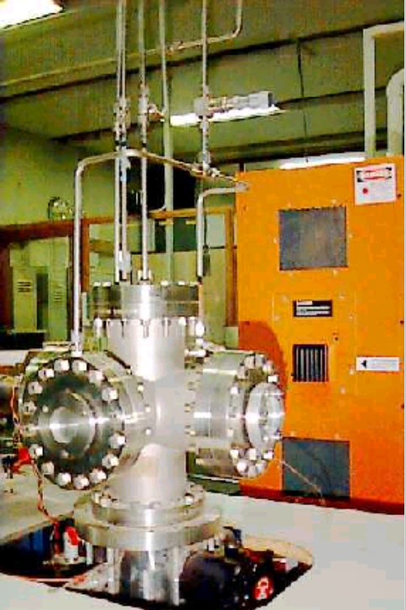

Currently, we are extending our studies to include device applications of low temperature grown GaN, in the direction of heteropolar devices such as light emitting diodes grown on glass and heterojunction bipolar transistors. For the project description click here (hyperlink to LCVD project)

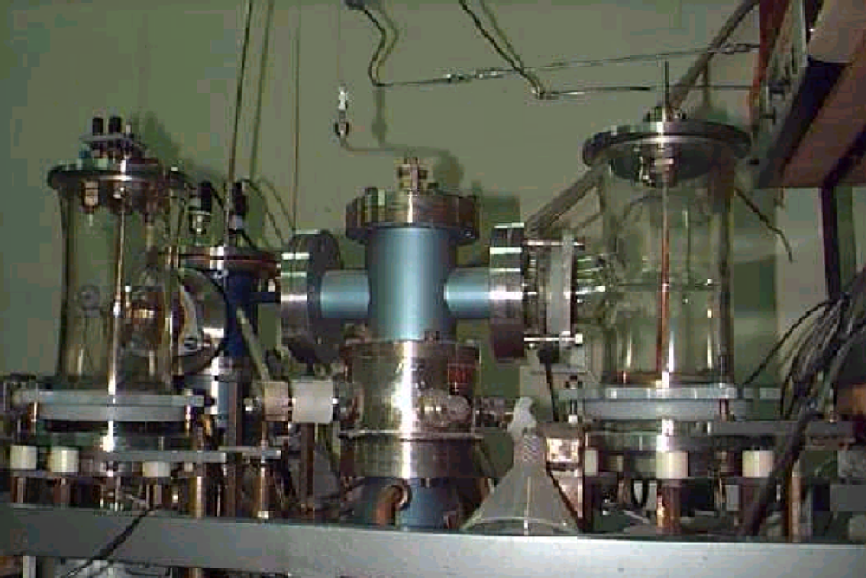
The sputtering unit which is still (2001) holding a 1986 world record for high mobility InN

Selected publications include:
- "Morphology and optical properties of laser-assisted chemical vapour deposited GaN", E.M. Goldys, M. Godlewski and T.L. Tansley, Acta Physica Polonica, vol 94, no 2 p.331-5, (1998).
- "Low temperature growth of gallium nitride on quartz and sapphire substrates", E.M. Goldys, M.J. Paterson, H.Y. Zuo, T.L. Tansley, Mater. Sci. Forum vol. 264-268 pt 2 p. 1205-8 (1998).
- H.Y. Zuo, M.J. Paterson, E.M. Goldys, T.L. Tansley and Afidudin, "Laser assisted metalorganic chemical vapour deposition of Mg-doped GaN on Silicon, Sapphire and GaAs", COMMAD 1998, 14-16 December 1998, Perth, page 199-201.
- H.Y Zuo, B. Zhou, E.M. Goldys, M. Paterson and T.L. Tansley, "The Influence of Different Substrates on GaN Films Grown by Low Temperature Laser and Plasma Enhanced MOCVD", Conference on Optoelectronic and Microelectronic Materials and Devices, COMMAD96 8-11 Dec. 1996 Canberra, p. 406, (1997).
- S. Kumar, E.M. Goldys, T.L. Tansley. C.T. Foxon, T.S. Cheng, and S.V. Novikov, "GaN Films Grown by Plasma Assisted Molecular Beam Epitaxy - Morphology and Microstructure Studies", Australian Compound Optoelectronic Materials and Devices Conference (COMAD), Sydney, 12-14 December 1994, p. 189-194.
- Z. Bing, X. Li, S. Butcher, E. Goldys and T.L. Tansley, "GaN growth and characterization measurements using ArF excimer laser", Australian Compound Optoelectronic Materials and Devices Conference (COMAD), Sydney, 12-14 December (1994), p. 171-173.
- H.Y. Zuo, M.J. Paterson, E.M. Goldys and T.L. Tansley, " Laser Assisted Metalorganic Chemical Vapour Deposition of Mg doped GaN on Silicon and GaAs", 10th AINSE Conference on Nuclear Techniques of Analysis and the 4th Vacuum Society of Australia Congress, Australian National University ACT, Australia, 23-26 November 1997.
- " Glass substrates for GaN using ZnO buffer layers", K.S.A. Butcher, Afifudin, P.P-T. Chen, M. Godlewski, A. Szczerbakow, E.M. Goldys, T.L. Tansley, J.A. Freitas Jr, 2000 Conference on Optoelectronic and Microelectronic Materials and Devices, Melbourne, Australia, 6-8 December 2000
- " Growth and Characterisation of GaN grown by microwave plasma assisted laser induced chemical vapour deposition", Afifudin, K.S.A. Butcher, P.P-T chen, E.M. Goldys, T.L. Tansley, 2000 Conference on Optoelectronic and Microelectronic Materials and Devices, Melbourne, Australia, 6-8 December 2000

(For more information contact Professor T.L. Tansley (hyperlink to home page) (trevor@ics.mq.edu.au) or Dr Scott Butcher (sbutcher@ics.mq.edu.au)

(Hyperlink to LCVD project )

DOPANTS, DEFECTS AND INTERFACES IN NITRIDE SEMICONDUCTOR ELECTRONICS

Project summary
The development of III-V nitride semiconductor growth and device processing technologies has seen rapid advances in GaN-based heterojunction bipolar transistors and transverse conductance devices for applications in high power/high speed electronics. Basic areas in which the technology depends critically on the engineering physics include high level doping, epitaxy on selected substrates, and determination of the effects of film anisotropy defects and interfaces, and built-in piezoelectric field effects on current transport. This project brings together unique in-house low-temperature growth and the experimental identification of those microproperties most importantly to be brought under control for desirable macroscopic outcomes in GaN-based electronics devices.

1.1 General Aim
Semiconducting nitrides have secured prominence through applications in light emitters in the blue-green to ultraviolet spectral range. This is despite a conspicuous failure to reduce the defect density to the levels essential in other semiconductors. The roles of dopant and other impurities, heterogeneity, especially in alloys, and of interfaces, are much more complex than in in conventional gallium arsenide based applications. While it is broadly clear that crystalline imperfections in nitrides have specific properties that minimise their potentially malign influence on the electrical and optical properties of the crystal, the details required for engineering design require further physical understanding. The present group of investigators have made significant contributions to the emerging understanding of material properties and now plan to use their microstructural analytic techniques and macroscopic characterisation expertise to better understand the relationships between dopant, impurity, defect and related effects and electronic device applications. The general context chosen is the study and optimisation of materials with applications in selected transverse conductance electronic devices. The behaviour of semiconductor interfaces and anisotropic microstructure thus also achieve importance. While this choice of device structures is motivated by the general international thrust in new nitride applications, the investigations we propose aim to further correlate the fundamental properties of nitrides with the parameters important in device engineering. Some device modelling is therefore included in the proposal.

1.2. Expected Outcomes
The general outcomes of the project will be a better understanding of the physical nature of the defects found in GaN and its alloys, and their consequences for forthcoming semiconductor devices.
- Advances in fundamental understanding of the re-equilibration of excess minority carrier populations.
- Advances in fundamental understanding of majority carrier transport as limited by scattering processes associated with defect structures.
- Development of in-house capabilities in device-related technologies, and the use of feedback from basic strucures to microscopic studies.
2. Research Plan
The core plan is based on two major elements, the availability of a unique low-temperature CVD system for binary and ternary nitrides with p and n doping and our laboratory facilities for characterisation and fabrication. Capabilities have been significantly advanced through US Navy support, which has allowed us to produce free-standing nitride films , 10um thick and separated by a lift-off technique.

We will examine the reasons for the observation that the defect-related microscopic properties of the semiconducting nitrides are significantly more benign in their consequences for the macroscopic behaviour of devices constructed from them than is typical of other compound semiconductors. This paradox is addressed through two parallel, crosslinked themes in the device engineering and materials physics of nitrides.

The physics theme is centred on the physics of defects in a range of nitride samples, grown in-house and elsewhere. The principal requirement is met by our capacity to characterise on microscopic and macroscopic scales, tasks which we approach as described in following sections. Tools to be used include cathodoluminescence mapping of emission spectra associated with microscopic features, atomic force microscopic analysis of surface morphology, high resolution transmission electron microscopy at atomic scale resolution and chemical microstructure via Auger/XPS. On the larger scale, majority carrier transport, minority carrier re-equilibration and photon/carrier interactions in films and at interfaces are to be studied.

The engineering theme focusses on the influence of defects on device-related properties, and requires us to develop and apply appropriate technologies. The technologies required for this project are the growth of semiconductor films and multilayers suitable for physical characterisation, and applications and fabrication techniques in device definition and contacting/metallisation. We are currently able to prepare gallium and aluminium nitrides of device quality and have demonstrated the ability to pattern films at submicron resolution using reactive-ion etching, and metalisation/contacting expertise.

3. Methods And Techniques
(a) Materials: A unique nitride growth method has been developed in which a 4mW ArF laser photolytically dissociates the trimethylgallium(TMGa) and ammonia precursors above the substrate without directly illuminating it. The advantage of this technique is that films can be produced at temperatures as low as 500C. Thus interlayer diffusion and surface degradation can be avoided. Laser CVD is also thought to be advantageous in reducing the nitrogen vacancies in GaN due to the temperature dependence of the partial pressure of nitrogen over GaN. In addition, the system utilises a 400 W Klystron microwave plasma source in a tunable cylindrical waveguide to inject low energy nitrogen radicals into the chamber to assist in the reduction of nitrogen vacancies. GaN produced using this integrated LTMOCVD facility has mobilities of 100-200 cm²/Vs and low background carrier concentrations of 10¹⁵-10¹⁶cm⁻³. This is the core facility for in-house growth and will be progressively developed during the course of the project. Technological capability is present in selective-area dry etching, contact metalisation and compatible AlN insulator overgrowth. AlGaN and InGaN are produced in our facility by introducing trimethyl aluminium (TMAl) and trimethylindium (TMIn) respectively.

As-deposited GaN is n-type and doping is necessary to produce p-type type material. Mg is a commonly used p-type acceptor in III-V nitride and bis (cyclopentadienyl) magnesium has been installed in the Macquarie system with room temperature hole mobilities of 40cm ²/Vs and concentrations of 10¹⁶ cm⁻³ thus far achieved without post-growth processing. Donor doping has been provided, both by control of nitrogen vacancies, a proven technique allowing variation over about 4 orders of magnitude, and by Si doping using tetraethylsilane.

(b) characterisation. Preliminary diagnostic techniques are important as initial guides to the quality of the films and selection for further study. These comprise photoluminescence (room temperature), UV-Vis-IR transmision spectroscopy and Hall effect measurements. Techniques routinely available in-house for more detailed study of seleced layers include photoluminescence (9K-RT) under Cd-He laser stimulation, photoreflectance (9K-RT), photoconductivity, IV, CV and correlation DLTS. Each of these techniques is to be applied following the standard practices of semiconductor materials analysis.

Microstructure-dependent properties are to be investigated in several ways. High Resolution Transmission Electron Microscopy (HRTEM), under fee-for-service arrangements with UTS, will examine in detail the crystal quality and structure of the films, and the interfaces in various heterostructures. Additional available techniques to be used include cathodoluminescence mapping at submicron resolution, X-ray diffraction and atomic force microscopy to examine emission distribution, crystal structure/orientation and surface morphology respectively. Low temperature cathodoluminescence within an ultrahigh resolution electron microscope will allow localised CL emissions to be resolved on the 5-10nm scale. These data will provide a comprehensive picture of microscopic properties.

Macroscopic property measurements, in addition to the optical methods above, will include Hall-van der Pauw measurements of carrier concentration and mobility over a wide temperature range. Gated measurements under bias will allow some depth profiling of these parameters. Transconductance of devices is to be measured as a function of temperature, current density and illumination conditions both with and without aluminium nitride overlayers using the high sensitivity electrometer, programmable current source and temperature control systems available in SSTL. These results will be applied to small-scale circuit design and fabrication. Static and dynamic parameters will be measured using the suite of instrumentation in the Division developed for similar work in the GaAs-based material system.

(c) Fabrication. All basic fabrication will be undertaken in our Class 35 semiconductor processing cleanroom where a full range of lithographic tools is available. The formation of mesas for photodetectors and etch-isolated MIS structures will be undertaken by Reactive Ion Etching (RIE). Etch rates above 0.1 µm/min are obtained in CCl₂F₂/Ar plasmas with a high GaN/AlN selectivity. The provision of low-ohmic contacts to the nitrides uses a metal multilayer schema.

(d) Device measurements and modelling : Features of designs will be numerically simulated and device properties evaluated. Of most importance are gain and noise, base transit time or transconductance, power handling capabilities, device bandwidth and temperature dependence. Parameters of device layers, primarily the compositions of ternary alloys, their doping levels and transport properties, will be varied in the calculations. Effects of device geometry will include the limitations of our selective etching and base-collector or gate formation processes. Material properties and their intrinsic limitations, identified in the relevant experimental studies, will be included in the modeling. The base or channel transit time will be investigated in the context of high frequency operation. State-of-the-art modeling will include partitioning of the total current into thermionic and tunneling components, as well as such important effects as bandgap narrowing , carrier saturation and piezoelectric fields. We will use computer codes derived from three activities:
- The commercial software packages MEDICI and DAVINCI (Technology Modeling Associates, CA, USA.) These provide two- and three-dimensional electrical analysis for advanced nonplanar applications, based on realistic physical models in which input parameters may be fully controlled by the user. Using these packages, effects such as current crowding may be simulated. Site-licence access has been secured.
- Software built in Macquarie’s Electronics Dept. during the design, modelling and fabrication of a world record unity gain frequency composite collector HBT fabricated in the GaAs-based materials system.
- Programs developed in Macquarie’s Physics Dept. specifically for the evaluation of the effects of fundamental quantum phenomena on electron transport across heterointerfaces.

4. Time sequence
2001 Select appropriate grown layers and multilayers for characterisation in Australia and the US. Acquire from associated overseas workers sample materials for comparative studies. Continue device processing developments and transconductance studies. Growth system development for GaN, AlGaN and InGaN films of varying composition with p and n doping experiments. Theoretical and experimental transport analyses, including basic simulations of device performance by incorporating fundamental physical data into advanced software packages.
2002 Dope GaN and bandgap tailored InGaN and AlGaN with Mg or C and Si to optimised levels. Conclude device fabrication protocols. Compare full suite of microscopic physical characterisation data with macroscopic properties.
2003 Build n-p and p-n InGaN/GaN and GaNAlGaN heterojunctions and Al/AlN/GaN MIS structures for high power transistors, compare experimental and predicted performance parameters. Feed device data back for correlation with physical characteristics and material optimisation.

(For more information contact Professor T.L. Tansley (hyperlink to home page) (trevor@ics.mq.edu.au) or Dr Scott Butcher (sbutcher@ics.mq.edu.au)

(End hyperlink to LCVD project)

III-V Nitrides (Associate Professor Ewa M. Goldys)

Gallium nitride and related compounds are emerging electronic material for the next generation electronic and optical devices. Further improvements in material quality are necessary for improved reliability and yield. Amongst the III-V nitrides, gallium nitride has generated most interest due to its application as a blue emitter. Alloys of GaN with indium and aluminum nitrides have also attracted attention as their bandgaps can be selected by compositional control, allowing materials to be produced with optical absorption tailored to ultraviolet wavelength bands.

Our present research program concentrates on the investigations of O and H content in GaN (hyperlink to O and H in GaN)

Our key experimental methods include cathodoluminescence (hyperlink to cathodoluminescence) , Raman ( hyperlink to Raman) and other optical spectroscopies.

Cathodoluminescence is based on the emission of light under intense bombardment using electrons in a specially adapted electron microscope, and it has very significant diagnostic powers including depth-profiling and defect electromigration.

The UV Raman spectroscopy is critical to studies of microstructure and local chemical compositions of nitride films grown at Macquarie University and other collaborating institutions. The excitation wavelength of 325 nm, in close proximity to an electric dipole allowed transition enhances the Raman signal by several orders of magnitude, so sensitive effects may be explored. A variety of film attributes is observed in their effect on the phonon modes. Microstructural information and in-depth resolution through Raman confocal operation is particularly valuable for examination of conventional GaN structures.

Our earlier work concentrated on fundamental studies of defects in GaN and other III-V nitrides by cathodoluminescence (in collaboration with M. Godlewski (Polish Academy of Sciences, and M.R. Phillips (University of Technology, Sydney) . These studies help unravel the role of defects for device properties of GaN and they both advance frontiers of scientific inquiry and provide foundation for future technological developments.

In particular

- we have identified principal reasons for film nonuniformities in HVPE growth and identified strategies for their elimination. Further work continues aimed at free-standing films.

- Raman spectroscopy was used to identify the structure of low temperature nitride films and provide information about the crystallite size, a very accurate measure of electronic quality of a semiconductor film, important in thin film characterisation and otherwise accessible only through time-consuming transmission electron microscopy.

- we have discovered in-plane nonuniformities in band-edge emission in MOCVD GaN, while lower energy emissions (yellow band) were found homogeneous.

- the significance of oxygen on the yellow emission was revealed for the first time.

Selected publications on these issues include:

- "Inter-link Between Structural and Optical Properties of GaN and GaN/AlGaN Heterostructures", M. Godlewski and E.M. Goldys to be included in the book ''III-V Nitride Semiconductors: Optical Properties''Hongxing Jiang and M. Omar Manasreh (Co-editors) to be published by Gordon and Breach. (114 pages, http:// www.physics.mq.edu.au/\ ~{goldys/files/review.pdf)

- "Characterisation of the red emission in nominally undoped HVPE GaN", E.M. Goldys, M. Godlewski, T. Paskova, G. Pozina, B. Monemar, MRS Internet Journal of Nitride Research, vol 6, paper 1 (2001).

- "Nonuniform defect distribution in GaN thin films examined by cathodoluminescence", E.M. Goldys and M. Godlewski, Applied Physics A - Materials Science and Processing , 70, 329, (2000)

- "Cathodoluminescence Studies of in-plane and in-depth Properties of GaN Epilayers", M. Godlewski, E.M. Goldys and M.R. Phillips, Journal of Luminescence 87-89, 1155 (2000).

- "Surface morphology of cubic and wurtzite GaN films" E.M. Goldys, M. Godlewski, R. Langer, A. Barski, Applied Surface Science 153, p. 143-149, (2000).

- " Cathodoluminescence Depth-profiling Studies of GaN/AlGaN Quantum Well Structures", M. Godlewski, E.M. Goldys, M.R. Phillips, R. Langer and A. Barski, J. Mat. Research, 15,p. 495-501,(2000).

- "Influence of growth rate on the structure of thick GaN layers by HVPE", T. Paskova, E.M. Goldys, R. Yakimova, E.B. Svedberg, A. Henry, and B. Monemar, J. Cryst. Growth, 208 p.18-26 (2000).

- "Hydride Vapour Phase Epitaxial GaN Layers Grown on a-plane Sapphire with Different Buffers", T. Paskova, J. Birch, S. Tungasmita, R. Beccard, M. Heuken. E.B. Svedberg, P. Runneson, E.M. Goldys and B. Monemar, physica status solidi a, 176, p. 415-19, (1999).

- "Analysis of the red optical emission in cubic GaN grown by MBE", E.M. Goldys, M. Godlewski, R. Langer, A. Barski, P. Bergman, B. Monemar, Phys. Rev. B, 60, p. 5464-9, (1999).
- T. Paskova, E.M. Goldys, B. Monemar. "Hydride vapour-phase epitaxy growth and cathodoluminescence characterisation of thick GaN films", J. Cryst. Growth, 203, p. 1-11, (1999).

- "Contribution of Free Electron Recombination to the Emission Spectra of GaN grown by HVPE", B. Arnaudov, T. Paskova, E.M. Goldys, R. Yakimova, I.G. Ivanov, S. Evtimova, A. Henry, B. Momenar, J. Appl. Phys. vol 85, (1999) pp.7888-92

- "Direct observation of large-scale nonuniformities in hydride vapor-phase epitaxy-grown gallium nitride by cathodoluminescence", E.M. Goldys, T. Paskova, I.G. Ivanov, B. Arnaudov, B. Monemar, Applied Physics Letters, vol 73, no 24, p. 3583-5, (1998).

- "Influence of the surface morphology on the yellow and "edge" emissions in wurtzite GaN", M. Godlewski, E.M. Goldys, M.R. Phillips, R. Langer and A. Barski, Applied Physics Letters, vol 73, no 25, p. 3686-8, (1998).

- "Morphology and Optical Properties of cubic phase GaN epilayers grown on (001) Si ", M. Godlewski, E.M. Goldys, M.R. Phillips, J.P. Bergman, B. Monemar, R. Langer, A. Barski, MRS Internet Journal of Nitride Semiconductor Research, vol 3, 51 (1998).

- "Mechanisms of red and yellow photoluminescence in wurtzite and cubic GaN" M. Godlewski, T. Suski, I. Grzegory, S. Porowski, R. Langer, A. Barski, J.P. Bergman, B. Monemar, E.M. Goldys, and M.R. Phillips. Acta Physica Polonica, vol 94 no 2 p.326-30 (1998).

16) S. Kumar, E.M. Goldys, T.L. Tansley. C.T. Foxon, T.S. Cheng, and S.V. Novikov, "GaN Films Grown by Plasma Assisted Molecular Beam Epitaxy - Morphology and Microstructure Studies", Australian Compound Optoelectronic Materials and Devices Conference (COMAD), Sydney, 12-14 December 1994, p. 189-194.

- "Zirconium Mediated Hydrogen Outdiffusion From p-GaN" E.Kaminska, A. Piotrowska, A. Barcz, M. Zielinski,R.F. Davis, M.D. Bremser, E. Goldys, K. Tomsia, Fall Meeting of the Materials Research Society, Boston, MA, 28 November - 3 December 1999, paper W10.9.1

- "Thermal Stability and Electrical Properties of Ti and Zr-based Nitrides and Borides on GaN (E.Kaminska, A.Piotrowska, A. Barcz, M. Guziewicz, K. Golaszewska, E.Goldys, K.Tomsia, J. Jasinski, J. Kozubowski, E.Dynowska, "Surface and Thin Films" Kazimierz Dolny, 15-18 Sept 1999, Poland to be published in Electron Technology.

- "Photo- and cathodoluminescence investigations of piezoelectric GaN/AlGaN quantum well structures", M.Godlewski, E.M.Goldys, M.R.Phillips, V. Yu Ivanov, R.Langer, A.Barski, 11-th International Semiconducting and Insulating Materials Conference Canberra Australia 3-7 July 2000.

- "Role of localisation effects in GaN and InGaN" (invited talk) M.Godlewski and E.M.Goldys. International Conference Advanced Optical Materials and Devices, ADOM-2, Vilnius, Lithuania, August 16-19, 2000, Proceedings SPIE (in print)

- "Photoluminescence and cathodoluminescence investigations of piezoelectric quantum wells" E. M. Goldys, M. Godlewski, M.R. Phillips, A.A. Toropov, Fall Meeting, Materials Research Society, Boston, MA, USA, 27 November - 1 December 2000.

- "Correlation between Hot Exciton Photoluminescence and Kelvin Probe Force Microscopy in p-type GaN" E.M. Goldys, M. Godlewski, E. Kaminska, A. Piotrowska, G. Koley, M.G. Spencer, L.F. Eastman, 2000 Conference on Optoelectronic and Microelectronic Materials and Devices, Melbourne, Australia, 6-8 December 2000.

- "Cathodoluminescence Study of Nitride Transistor Structures-Characterisation of Native Oxide", E.M. Goldys, T. Paskova, J. Sheely, W. Schaff, L.F. Eastman, 2000 Conference on Optoelectronic and Microelectronic Materials and Devices, Melbourne, Australia, 6-8 December 2000

- " In-plane and in-depths nonuniformities in defect distribution in GaN and InGaN epilayers, M. Godlewski, E.M. Goldys, G. Pozina, B. Monemar, K. Pakula, J.M. Baranowski, P. Prystawko and M. Leszczynski, ICDS21

(For more information contact Associate Professor Ewa Goldys (hyperlink to home page) (goldys@ics.mq.edu.au)

hyperlink to cathodoluminescence

Cathodoluminescence emission is the emission of light of a specimen when bombarded with an electron beam in a specially equipped electron microscope. The spectral content of the light emitted from a material irradiated by electrons contains information on the impurities in semiconductors. Monochromatic CL imaging allows for imaging of lateral distribution of impurities. Optically inactive centres may inhibit the CL emission and, consequently, affect the intensity of the detected CL signal. CL measured as a function of electron beam energy can provide insight into the depth distribution of the relevant centres. At a given beam energy the generation of CL as a function of depth can be modeled using Monte Carlo techniques, and, in conjunction with the measured spectra, it provides information on the density of the impurity at a given distance from the film surface. CL kinetics is obtained by measuring CL intensities as a function of electron beam irradiation time. This irradiation in resistive specimens creates strong electric field, and the electromigration of charged defects and impurities. Cathodoluminescence offers a very powerful capability of studying the evolution of the CL spectra as a function of the excitation current density over a very wide range of currents. The cathodoluminescence spectra need to be corrected for the response of the detection and measurement system, deconvoluted and typically curve fitted using Gaussian curve fitting techniques. The Gaussian peak parameters (energy, FWHM and intensity) can then be carefully monitored as a function of experiment parameters, such as beam energy, temperature and irradiation dose. Once the CL peak positions and halfwidths are known, monochromatic high spatial resolution maps can be measured to provide information on the distribution and relative concentration of the luminescent defects. The CL maps will be compared with the high sensitivity wavelength dispersive spectrometry (WDS) X-ray maps acquired from the same regions using binary logic false colouring overlay techniques to detect regions of high correlation or anticorrelation. These composite CL and WDS maps can then be used to assign CL emission peaks to specific extrinsic impurities.

Cathodoluminescence spectroscopy with its mapping capabilities can be used to assess the defect concentration and/or compensation in a variety of approaches. Detailed empirical studies of the edge emission in a series of carefully calibrated specimens have been used earlier as a benchmark for shallow impurity content and/or compensation in other materials. The properties of the edge emission reflecting the impurity content and compensation include the relative intensities of various spectral features and their line shapes. In order to make an accurate assessment of the line shape the obtained spectra need to be corrected for the system’s response and employ peak-fitting procedures in conjunction with existing theories of the line-shape to arrive at the quantities of interest. The calibrated edge emission can be productively used to determine the impurity concentration over a wide range of densities, likely between high 10¹⁸ cm⁻³ and 10¹⁴-10¹⁵ cm⁻³ Importantly, the edge emission can be used in a mapping mode and in the “spot” mode, thus revealing nonuniformities of electrical properties.

End hyperlink to cathodoluminescence
(hyperlink to O and H in GaN)

“Development of methodology to determine O(H) content in GaN”
Project description

1. Aims and Significance
The general aim of our project is to develop a suite of spectroscopic assessment methods of oxygen and hydrogen (O(H)) content in gallium nitride (GaN). These methods will have important mapping capabilities. Further, we aim to apply these methods to investigate the influence of these important inadvertent impurities in practical growth and post-growth processing techniques. We aim to solve a range of specific problems in GaN such as doping, compensation, impurity correlation and ohmic contact stability which require such analysis tools. Advanced materials such as GaN represent the frontier for microelectronic and optoelectronic device applications. The outcomes will help establish the optimum conditions for the manufacture and processing technologies of high quality GaN films for applications in the microelectronics industry. The proposed investigations are aiming to make further distinctive advances in engineering of materials properties for improved device technologies.

1.1 Expected outcomes:
The results will be of both scientific and industrial significance in that they will contribute new knowledge of doping and compensation mechanisms in GaN, address limitations of existing technologies for p-type contact formation using hydrogen-drawing Zr layers and develop a unique set of tools for fingerprinting and mapping of O and H in GaN. All these outcomes are of special interest from an engineering point of view and necessary for the improvement of electronic and optoelectronic GaN devices.

1.2. Issues of significance in GaN technology
In the last five years GaN and related compounds have emerged as the key materials for applications in light-emitting devices such as blue diodes, short wavelength lasers, UV-sensitive light detectors, and in high temperature high power electronics. Applications in high-density optical data storage (one of the fastest growing sectors in this multibillion dollar industry), medical imaging and diagnosis, and high temperature chemical detection/monitoring help motivate the program. There has been a substantial worldwide interest in the development of GaN-based low-noise circuit elements, particularly transistors with superior characteristics.

The fundamental material properties of GaN such as its high direct bandgap and excellent thermal characteristics ensure its dominant role in future generation optoelectronic and electronics devices. However the capabilities of these devices presently fall short of the requirements for long lifetime, high electron mobility and low and stable p-type contact resistance. It is well known that GaN films generally suffer from poor lattice matching to the substrate, typically sapphire. Notable advances have been made in the past several years in the development of low temperature buffers which facilitate growth on such lattice mismatched substrates by acting as fairly efficient barriers for dislocation propagation. Thanks to these developments, industrial GaN growth processes by metalorganic chemical vapour deposition (MOCVD), Molecular Beam Epitaxy (MBE) and Hydride Vapour Phase Epitaxy (HVPE) are now available. However, as we have recently found, structural defects such as dislocations are still present, accompanied by a range of secondary effects such as accumulation of impurities in the vicinity of structural defects. These phenomena, are facilitated by high growth temperature, in MOCVD and HVPE. Some of the impurities, such as hydrogen are inadvertently present in the MOCVD and HVPE growth environment, others, such as oxygen, may be present only in residual quantities but seem to be preferentially incorporated. As a result the quality of these materials, particularly the in-plane and in-depth uniformity required by device technologies, and the effectiveness of the processing methods, for example for p-type contact formation, critically depend on the way the inadvertent impurities are incorporated. Methods of defect assessment and control are thus believed to be one of the remaining critical issues in GaN technology.

1.3. How the present project will address these issues of significance
In the last two years we have completed independent studies on the role of defects in GaN films, particularly of oxygen, hydrogen, and native defects and their interaction with structural defects. We have achieved results on the existence of the dislocation networks on the surface of commercial GaN films very similar to those reported elsewhere. We have also reported novel results relating to the use of cathodoluminescence imaging and depth profiling as a tool to assess uniformity of the films. In the case of oxygen- and hydrogen-related defects, we have led the way internationally including demonstrations of the role of these impurities in the important yellow emission in GaN. We have identified a similar red emission in cubic GaN grown by MBE, and demonstrated its link to similar defects as those responsible for the yellow emission.

1.3.1 Motivation to study oxygen in GaN
The full significance of oxygen in GaN has just begun to emerge. Below we present the key issues that we plan to resolve within this project once sensitive methods to quantify the content of electrically active oxygen and hydrogen become available.

- Oxygen doping of GaN: Oxygen is known to be an n-type dopant that can be incorporated at very high densities, leading to metallic conductivity in bulk GaN grown under high pressure. Its potential as an industrial n-type dopant superior to the presently used Si can only be realised if oxygen can be introduced in a controlled manner and monitored. The role of O in nominally undoped GaN has not been fully explored as well. Undoped GaN is generally strongly n-type with room temperature free electron concentration in excess of 10¹⁷ cm⁻³. The autodoping process has been attributed to nitrogen vacancies as well as to O and other impurities , but it has not yet been fully clarified. We will be in a position to address the issue of autodoping, if we develop methods of oxygen detection that are both quantitative and sensitive to electrically active oxygen to a sufficient degree.

b) Nonuniformities of resistivity due to oxygen: We have reasons to believe that the present MOCVD and HVPE GaN films may have spatially nonuniform electrical properties because of preferential oxygen incorporation in the region of enhanced density of structural defects. In this project we wish to test the latter hypothesis. Detrimental consequences of planar and in-depth nonuniformities are anticipated for device technologies, particularly for high power devices. Our preliminary studies of MOCVD GaN including the world first demonstration of oxygen involvement in the yellow emission point to the link between oxygen incorporation and structural defects. Previously only indirect evidence was available, (see for example a theoretical report by Eisner et al) of preferential incorporation of oxygen into the core of certain dislocations, but, on the other hand, numerous earlier reports relate the yellow emission to structural defects thus bridging the link. In a separate work we have observed a granular structure in the edge emission in GaN due to grouping of dislocations. Thus, if oxygen indeed accumulates at these dislocations, it may locally increase the electron concentration and lead to nonuniformities of electrical properties. By contrast, we have already extensively characterised HVPE GaN grown on sapphire and identified distinctive regions of a greatly enhanced electron concentration in distinctive areas in the near-interface region where dislocations would accumulate. Importantly, in a recent work we have shown that this effect is absent in HVPE GaN grown on a MOCVD GaN template, thus revealing the link between an enhanced electron concentration and dislocations. Oxygen is a likely candidate to be the cause of this enhanced electron concentration, as it yields shallow donor states. However an assessment technique is required to properly judge the quantity of oxygen in these highly conductive regions.

c) Oxygen as a compensator in p-type doping: Oxygen is also theoretically postulated to be an important contributor to compensation in p-type Mg-doped GaN. It is anticipated that magnesium is preferentially incorporated in the immediate proximity of oxygen, if the latter is present. The resulting Mg-O pairs are electrically inactive. Experimental identification of such pairs would contribute to future better control of p-type doping in GaN.

On the basis of the above is clear that an extensive evaluation of the process of oxygen incorporation must be undertaken for a proper control of oxygen in growing GaN films to be of industrial significance. Such evaluation is only possible if methods to quantify the amount of oxygen in various lattice locations can be developed.

The first major aim of this project is thus to complete comprehensive experimental investigations of the signature characteristics of oxygen in GaN films. We anticipate to develop procedures based on various optical spectroscopies and mapping that will enable us to gauge the concentration of residual electrically active oxygen in the GaN films, as well as its spatial distribution in the films. We intend to pursue this as a spectroscopic sensing strategy for applications in industry. These studies will be carried out in conjunction with microstructural characterisations. We will gain important insights on the link between oxygen and various structural defects, and their respective emission fingerprints (yellow luminescence, donor-acceptor pair and bound exciton emissions). As oxygen is a common contaminant, we will aim to fully elucidate the mechanism involved in auto-doping and self-compensation in n-GaN as well as compensation in p-GaN.

1.3.2. Motivation to study hydrogen in GaN
The synthesis of post-growth activated p-type GaN in 1989 and the realisation of elevated hole concentrations in the early nineties has stimulated a rapid progress of GaN device technologies. However further increases in the doping level in the p-type material appeared to be more difficult. Reasons for this are not presently known, but it is widely suspected that hydrogen may be responsible. At the same time, hole mobilities are extremely low, suggesting very high levels of compensation. Thus one of the key problems which we plan to address is:

- the role of hydrogen in p-type doping. Mg-doped GaN is generally grown in the presence of hydrogen with an attendant advantage of minimising acceptor compensation by native donor defects. The Mg acceptors after the growth are not electrically active and require activation by either annealing in a nitrogen atmosphere or by low energy electron beam irradiation. The activation process has been attributed to the dissociation of Mg-N-H complexes and subsequent removal of H [18]. However, there are major inconsistencies on the reported effects of H on the photoluminescence spectra of Mg-doped GaN [19]. Recent theoretical studies suggest that the H behaviour is more complex than the mere formation and dissociation of Mg-N-H complexes. This is supported by the research on stability of contacts to p-type material, which appear to deteriorate with time. Thus the second problem that we plan to investigate is:
- The second major aim is thus to identify the optimum conditions for activation of p-type dopants through the studies of hydrogen content in GaN and the role of hydrogen in dopant deactivation processess. These investigations will include development of the p-type ohmic contact technologies meeting appropriate requirements of contact stability using hydrogen-drawing zirconium layers. The relevant outcome will have direct implications for device technologies, and also will offer a unique testing ground to understand the incorporation of hydrogen and its interaction with other defects. In parallel to a similar aim with respect to oxygen, this project aims to devise a spectroscopically useful method of fingerprinting of hydrogen in the GaN films.

(For more information contact Associate Professor Ewa Goldys (hyperlink to home page) (goldys@ics.mq.edu.au)

(end hyperlink to O and H in GaN)

Piezoelectric and Ferroelectric Materials (Dr I.L. Guy)

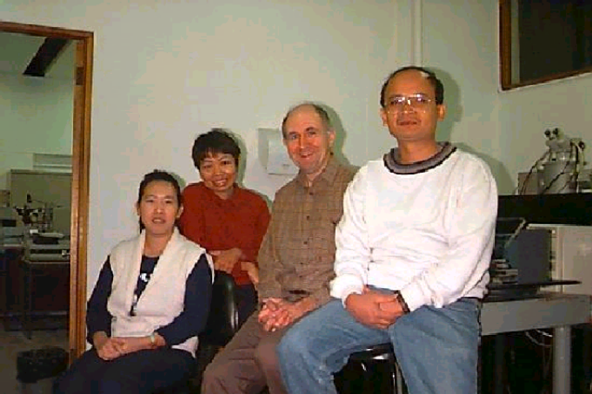
Major interest is centred in the area of ferroelectric polymers. Currently attention is centred on measuring the pyroelectric and piezoelectric properties of very thin (~ 100 nm) films of these polymers. In addition, conductivity, dielectric properties and polarisation hysteresis has been measured. Non-linear optical properties are also of interest.

From left to right: Zhenji, Wan, Dr Ian Guy, Limbong.

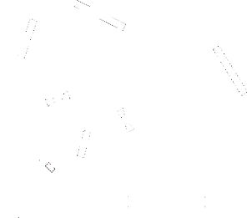
We aim to produce measurements of the piezoelectric coefficients of some compound semiconductors. The main interest is in group III-V compounds, particularly GaAs, GaN and AlN. The measurements are normally performed using an optical interferometer. Other techniques are also being investigated in order to obtain some of the more elusive coefficients. It seems that there is some non-linearity in the electromechanical behaviour of these materials and the possibility of a significant electrostrictive contribution is also being investigated.

A schematic diagram of a Michelson-Morley interferometer used to measure displacements of film surface with accuracy as high as 0.3 Angstrom. Using this system we can measure piezoelectric effects in films which are about 1 micrometer thin.

Selected publications include:
- "Extensional Piezoelectric Coefficients of Gallium Nitride and Aluminium Nitride", I.L. Guy, S. Muensit, E. M. Goldys, Applied Physics Letters {\bf 75}, p. 4133-5, (1999).
- "Electrostriction in GaN", S. Muensit, I.L. Guy, E.M. Goldys, Appl. Phys. Lett. {\bf 75}, 3641-3, (1999)
- "Shear Piezoelectric Coefficients of Gallium Nitride and Aluminium Nitride", S. Muensit, E. M. Goldys, I.L. Guy, Appl. Phys. Lett., {\bf 75}, p. 3965-7, (1999).
- "Measurements of piezoelectric coefficients of nitride semiconductor films", I.L. Guy, E.M.Goldys, S. Muensit, 11-th International Semiconducting and Insulating Materials Conference Canberra Australia 3-7 July 2000.

(For more information contact Dr I.L. Guy (hyperlink to home page) (iguy@ics.mq.edu.au)

Quantum confinement (Associate Professor Ewa M. Goldys)

This research concentrated on these quantum confinement effects which are relevant for electronic and optoelectronic devices.
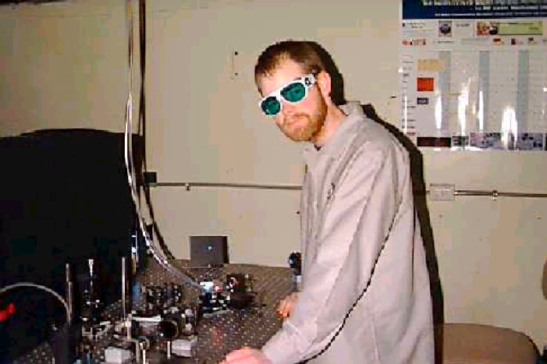
Dr Graeme Nott (BTech Opto) made important contributions to research on SEED devices. He is now with Herriott-Watt University in Edinburgh. In his PhD he studied selected device aspects of GaAs/AlGaAs multiple quantum well structures Modelling work revolved around the design of electro-absorption microcavities and investigating the associated material properties, such as refractive index. Devices being investigated utilise both standard and non-standard bandedge profiles and are being used as transmission and reflection irradiance modulators. Individual modulators are being combined into the common self electro-optic effect device (SEED) configuration for implementation of logical functions. The operation of symmetric SEED's is being investigated for application to optical oversampled analog-to-digital conversion applications.

Selected publications include:

- "Signatures of excitonic dark states in time-resolved coherent response of a microcavity", E.M. Goldys, G.C. La Rocca, F. Bassani, Phys. Rev. B 61, 10 346 - 10 360, (2000)
- "Optical-phonon modes and electron-phonon interaction in arbitrary semiconductor planar microcavities" Jun-jie Shi, B.C. Sanders, Shao-hua Pan, E.M. Goldys, Phys Rev. B 60, 16031-8, (1999).
- Jun-jie Shi, B.C. Sanders, Shao-hua Pan, and E.M. Goldys"Optical waves in a semiconductor planar microcavity"phys. stat. sol. b, 215, p. 1157-63 (1999).
- "Intersubband Optical Absorption in Strained Double Barrier Quantum Well Infrared Photodetectors" , Jun-jie Shi and E.M. Goldys, IEEE Transactions on Electron Devices, vol 46 no 1, p 83-8. (1999)
- "Inter-island energy transfer and in-plane exciton migration in AlGaAs/GaAs quantum wells detected by exciton dynamics" , M. Godlewski, P.O. Holz, J.P. Bergman, B. Monemar, K. Reginski, M. Bugajski, E.M. Goldys, T.L. Tansley, Superlattices and Microstructures, vol 23, p.107-11 (1998).
- "Band offsets in In_0.15Ga0.85As/GaAs and in In0.15Ga _0.85As/Al_0.15Ga0.85As studied by photoluminescence and cathodoluminescence", E.M. Goldys, H.Y. Zuo, M.R. Phillips, C.M. Contessa, T.L. Tansley, Superlattices and Microstructures vol 23, no 6, p. 1223-6, (1998).
- "Operation and Theoretical Analysis of the Multiple Asymmetric Coupled Quantum Well Light Modulator in the n-i-n Configuration", E.M. Goldys, G. Nott, T.L. Tansley, M. Henini, M.A. Pate, G. Hill, Journal of Quantum Electronics vol 33 no 7 p 1084-8 (1997).
- "Type I and type II Alignment of the Light Hole Band in In_0.15Ga_0.85As/GaAs and in In_0.15Ga_0.85As/Al_0.15Ga_0.85As Strained Quantum Wells" E.M. Goldys, H.Y. Zuo,M.R. Phillips, C.M. Contessa, M.R. Vaughan, T.L. Tansley, Journal of Electronic Materials, 28, no 8, 922-927. (1997).
- "Photoreflectance of AlxGa1-xAs/GaAs and GaAs/GaAs Interfaces at High Powers", E.M. Goldys, A. Mitchell, T.L. Tansley, R.J. Egan and A. Clark, Optics Communications, vol 124, no 3-4 p. 392-9, (1996).
- "The Current-Voltage Nonlinearity in the Multiple Quantum Well n-i-n Modulator Structure E.M. Goldys, G.Nott, T.L. Tansley, M. Henini, M.A. Pate, G. Hill, Electronics Letters, vol. 31 no 23 p. 2040-1, (1995).
- "Bound and Continuum Hole States in Semiconductor Quantum-well Structures with Arbitrary Potential Profiles", V.I. Galiev, E.M. Goldys, A.N. Kruglov, M.G. Novak, A.F. Polupanov, T.L. Tansley, International Journal of Physics of Low-dimensional Structures 12 , 317 (1995).
- "Exact Hole-Bound State Calculations for Semiconductor Quantum Wells with Arbitrary Potential Profiles", V.I. Galiev, E.M. Goldys, M.G. Novak, A.F. Polupanov, T.L. Tansley, Superlattices and Microstructures , vol. 17, p. 421-9, (1995).
- "Quantum Confined Light Modulators",E.M. Goldys and T.L. Tansley, Microelectronics Journal, vol 25. no 8, p.697-712 (1994) (invited review paper).
- "Electronic Band Structure of AlxGa1-xAs /AlyGa1-yAs/GaAs Double Barrier Superlattices", T. Osotchan, V.W.L. Chin, M.R. Vaughan, T.L. Tansley, E.M. Goldys, Phys. Rev B. vol. 50, no 4, p. 2409-19, (1994).
- "Photoluminescence Excitation Interpreted by Photon Recycling in GaAs/GaAlAs Multiple Quantum Well Structure", E.M. Goldys, V.W.L. Chin, T.L. Tansley, M.R. Vaughan, Journal of Applied Physics, vol.75, no.8, p. 4194-200, (1994).
- "High Field Photoluminescence in GaAs Single Heterojunctions: Mapping of an Optically Determined Phase Boundary Correlated with the Electron Liquid-Solid Transition", A.G. Davies, S.A. Brown, R.B. Dunford, E.M. Goldys, R. Newbury, R.G. Clark, P.E. Simmonds, J.J. Harris, C.T. Foxon, Physica B, vol.184, no.1-4, p. 56-65, (1993).
- "Magneto-photoluminescence Studies of a 2D Electron System: Signatures of the Fractional Quantum Hall Effect and Wigner Solid", S.A. Brown, A.G. Davies, R.B. Dunford, E.M. Goldys, R. Newbury, R.G. Clark, P.E. Simmonds, J.J. Harris, C.T. Foxon, Superlattices and Microstructures, vol.12, no.4, p. 433-42, (1992).
- "Magneto-optical Probe of Two-dimensional Electron Liquid and Solid Phases", E.M. Goldys, S.A. Brown, R.G. Dunford, A.G. Davies, R. Newbury, R.G. Clark, P.E. Simmonds, J.J. Harris, C.T. Foxon, Physical Review B (Rapid Communications), vol.46, no.12, p. 7957-60, (1992).
- "Improving performance of resonant tunneling devices in asymmetric structures", Jun-jie Shi, B.C. Sanders, Shao-hua Pan, E.M. Goldys, accepted in Physica E.
- "Excitons in quantum-dot quantum well nanoparticles", Jun-jie Shi and E.M. Goldys, submitted to physica status solidi b.
- "Accurate modelling of absorption and refractive in a GaAs/GaAlAs quantum well", G.J. Nott, E.M. Goldys, COMMAD 1998, 14-16 December 1998, Perth page 526-529.
- V.I. Galiev, E.M. Goldys, A.N. Kruglov, A.F. Polupanov, T.L. Tansley, "Realistic continuum hole states in Si-SiGe quantum wells", Conference on Optoelectronic and Microelectronic Materials and Devices, COMMAD96 8-11 Dec. 1996 Canberra, p. 333, (1997).
- A. Mitchell, E.M. Goldys, M.W. Austin and G.J. Nott "Design of Quantum Well Materials for Maximum Change in Refractive Index in Electric Field with Minimal Loss", Conference on Optoelectronic and Microelectronic Materials and Devices, COMMAD96 8-11 Dec. 1996 Canberra, p.83, (1997).
- G.J. Nott, E.M. Goldys, K.J. Grant, ''Simulation of Optical Oversampled Analog-to Digital Conversion Using Self-Electrooptic Effect Devices'', International Quantum Electronics Conference, 1996 OSA Technical Digest Series (Optical Society of America, Washington, D.C., 1996, pp 100-101 (1997).
- "Effect of Component Nonidealities on Optical Oversampled Analog to Digital Converter Resolution", G.J. Nott, K.J. Grant, E.M. Goldys, Proceedings, Fourth International Symposium on Signal Processing and its Applications, (ISSPA96), Gold Coast, Australia, 26-28 August 1996, vol 2, p. 853, (1997).
- E.M. Goldys, G. Nott, T.L. Tansley, M. Henini, M.A. Pate, G. Hill, "Quantum Confined Stark Effect in Coupled Quantum Wells and its Application for Light Modulation", Proceedings of Australian Compound Optoelectronic Materials and Devices Conference (COMAD), Sydney, 12-14 December 1994, p. 111-115.
- "Magneto-optics as a Probe of the Cross-over from the Fractional QHE to the Electron Solid Regime", S.A. Brown, E.M. Goldys, R.B. Dunford, A.G. Davies, R. Newbury, R.G. Clark, P.E. Simmonds, J.J. Harris, C.T. Foxon, 21th International Conference on the Physics of Semiconductors, Beijing, China, p. 931, 10 - 14 August, (1992).
- G.J. Nott, E.M. Goldys, K.J. Grant, ''Simulation of Optical Oversampled Analog-to Digital Conversion Using Self-Electrooptic Effect Devices'', International Quantum Electronics Conference, 1996 OSA Technical Digest Series Optical Society of America, Washington, D.C., 1996, pp 100-101
- C. Contessa, E.M. Goldys, M. Philips, M. Vaughan, "Cathodoluminescence Study of Strained AlGaAs /InGaAs and GaAs/InGaAs Quantum Wells", Australian Compound Optoelectronic Materials and Devices Conference (COMAD), Sydney, 12-14 December (1994).
- M. Godlewski, E.M. Goldys, M.R. Phillips, R. Langer, A. Barski, " In-plane and In-depth Properties of GaN Epilayers and GaN/AlGaN Quantum Well Structures Studied with Scanning and Depth-profiling Cathodoluminescence", Third International Conference on Nitride Semiconductors, Montpellier'99 (July 4-9, 1999), Montpellier, France.
- A.F.Polupanov, V.I. Galiev, A.N. Kruglov, E.M. Goldys, T.L.Tansley "Scattering of holes by quantum-well heterostructure", Proceedings of the International Symposium: Nanostructures 97: Physics and Technology, St.Petersburg 23-27 June 1997, pp. 118-121

M.A. Cusack, P.R. Briddon, M. Jaros, Phys. Rev. B, 56, 4047, (1997), see also S. Sauvage, P. Bocaud, J-M. Geraud, V. Thierry-Mieg, Phys. Rev. B, 58, 10 562, (1998), D. Pan, Y.P. Zeng, M.Y. Kong, J. Wu, Y.Q. Zhu, C.H. Zhang, J.M. Li, C.Y. Wang, Electron. Lett., 32, 1726, (1996).
see A.W.E. Minnaert et al, 24th ICPS, Jerusalem, Israel, 2-7 August 1998, MoP-139.

